Homework solution- Marcin Bułka

Task 1:

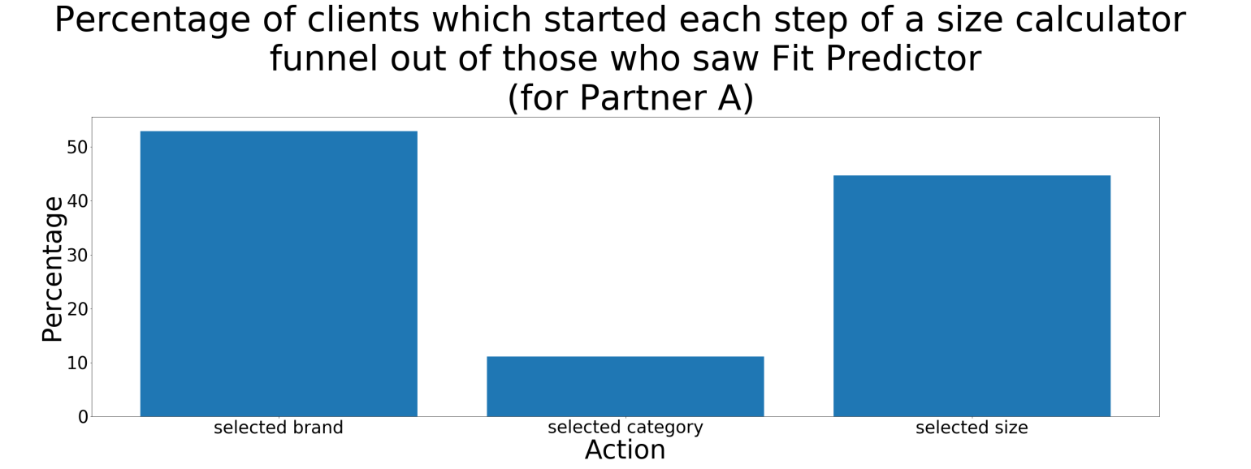

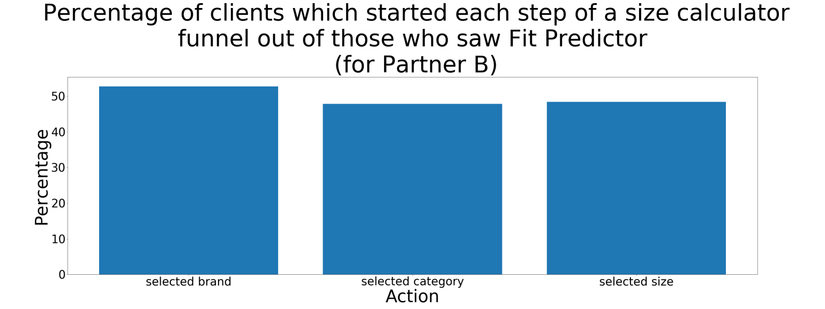

Task 2:

For Partner A we see that there is much smaller percentage of customers who select category, a possible reason for that might be that for Partner A’s websites there are more products for which Fit Predictor doesn’t have a category field to select.

Task 3:

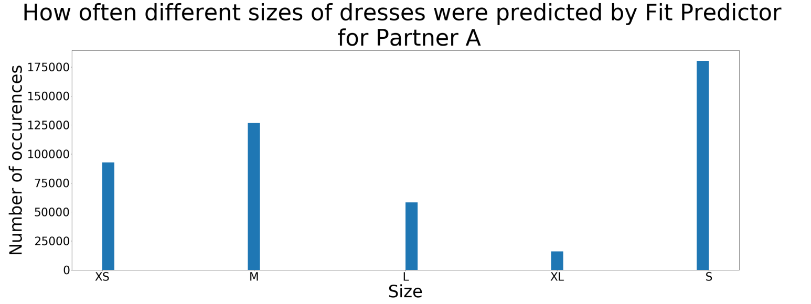

Task 4:

The conversion rate difference (CR_test - CR_control) is equal to 0.0009. This values is not statistically significant because 95% confidence interval for that difference is [-0.0003 : 0.002]. Our value 0.0009 is only an estimation of a real conversion rate difference so there is a chance that the real conversion rate difference equals to 0 or is even negative.

